Practical No. 17
Aim : WAP to demonstrate the use of following module :
- Math module 2. Random module 3. OS module

Name : Danish Altaf Solkar | Class : CO - B
Enrolment no. : 24111590805 | Batch : 2

- WAP to display calendar of given month using Calendar module
Code :-
import calendar
year = int(input("Enter year: "))
month = int(input("Enter month: "))
cal = calendar.month(year, month)
print("\nCalendar:\n")
print(cal)

OUTPUT :-
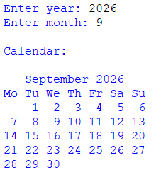
- WAP to calculate area of circle using inbuilt Math module.

Code :-
import math
r = float(input("Enter radius of circle: "))
area = math.pi * r * r
print("Area of circle =", area)

OUTPUT :-
